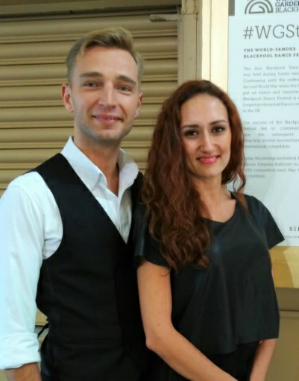
July 2020
Denis Parfyonov and Tania Sopit (Parfyonov)
Kyiv, Ukraine
Due to quarantine time we have to work by internet with children of different levels and ages. We want to share some of our notes.
- There is not so much space for dancing at home, so we can't work much for example at moving or dynamics. We work more on each part of the body: foot work, hips, hands, head work, such motions as rise and fall, CBM, CBMP, sway, dancing positions etc. We do dance exercises, learn new figures and of course do physical training!

- Now we have time to watch dance videos to learn dance history and a history of champions to have more understanding and inspiration! Use this theme for an online lesson: give pupils a task to watch, learn, compare some videos or find an interesting biography of legendary dancers.
3. Working with small children I understood they can copy me only in the mirror. Their right leg is my left one. Their turn to right is my turn to left etc. So the teacher must be very, very careful with it and have to change his demonstration. For example: if I want to do natural turn in waltz, I would start with left leg and will turn to the left. In this way children will look at monitor and copy my movements like they look in a mirror: right leg and right turn.
4. It’s time to try something new: pilates, ballet, yoga, salsa, zumba, modern or contemporary dance. Which will open mind more and teach the body new motions and feelings, which we can use in ballroom dance later.
5. It’s time to work on our emotions. Different figures will have different emotion.
6. We can also give tasks which will turn on imagination. For example: draw how you imagine slow waltz, or which color is tango.

We feel as teachers and dancers we have to use this difficult time with benefit and patience and just continue to love what we do.
With best wishes, Tania & Denis

